**Merge the small files in Hadoop:**

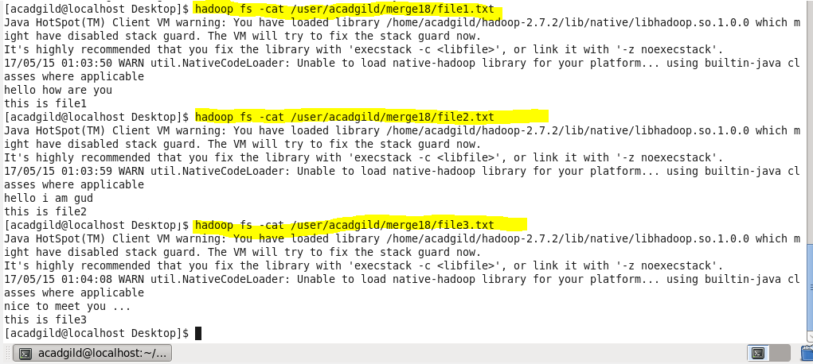

**Merging files without new line:**

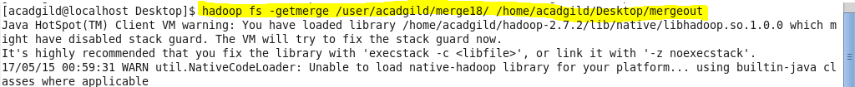

**Merging files with new line between files:**

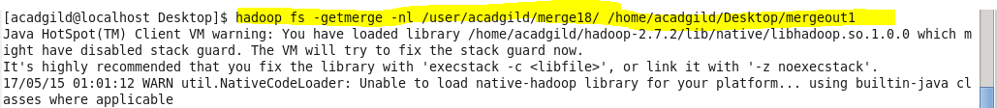

**Output:**

